Edge cells analysis

# Two environments experiment (L shape vs. linear):

Commit: 7a87cdc

I wanted to examine where edge cells from environment fire at another environment.

To do so, I used the data from the two environments experiment (elife 2015, c6m4, c7m4, c11m1, c13m1). I used the **elaborated events matrix**, meaning that entry of the matrix was ‘1’ from the rise time and until the peak of the event. Each track was divided into **12 bins**, and the first and last **2 bins were the “edges”** of the track. Edge cells were defined as cells that were active at the **first 2 seconds of arriving at the edge**, for **50% of their activity**, with **minimum number of 10 events** to the entire session. (the reason that it is different from the previous definition is because it is using the PPGUI data in long tracks (100 cm))

After finding for each session its edge cells, I looked at each edge cell’s histogram of events per bin (from both environments) and correlated between them. It is not necessary that edge cell that passed the criterion in one environment will pass it on the other environment as well, but the idea is to see that even when the cell does not pass the criterion, it preserves its firing location. I then looked at the fraction of cells with correlation above 0.65 for each mouse: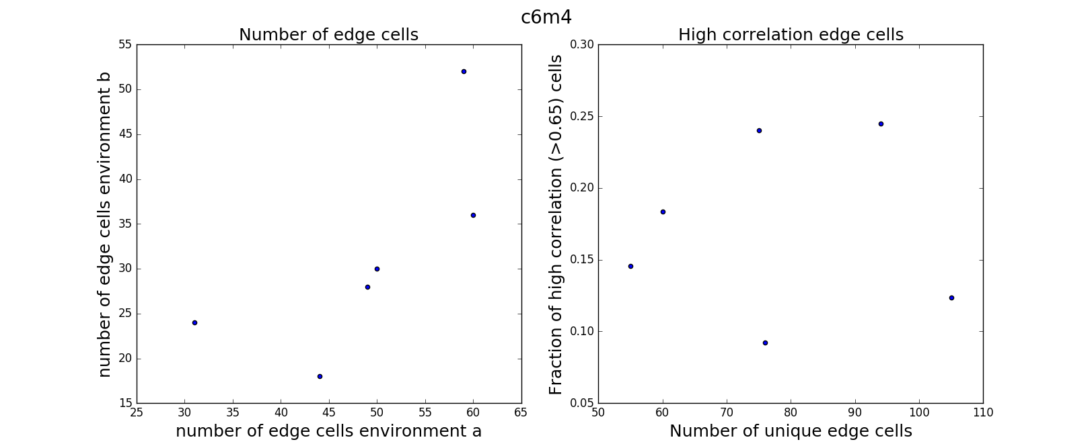

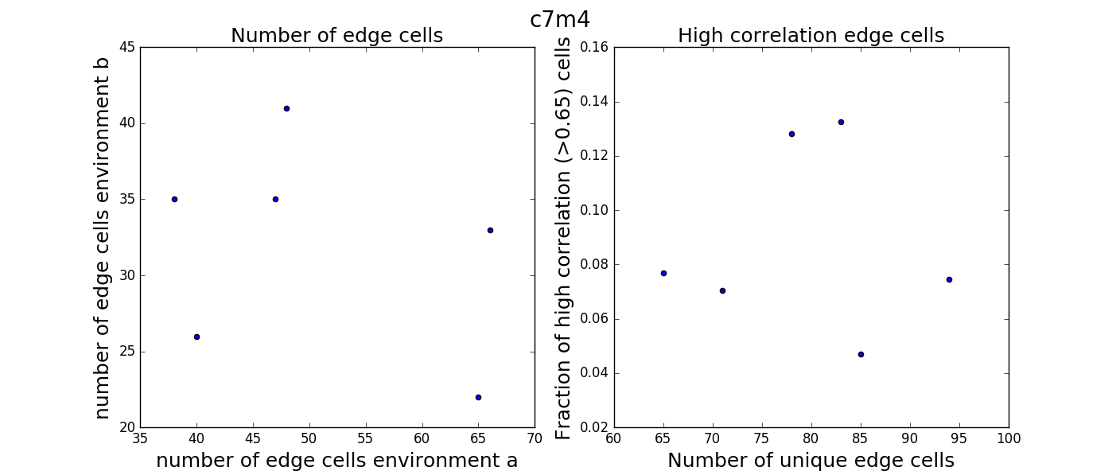

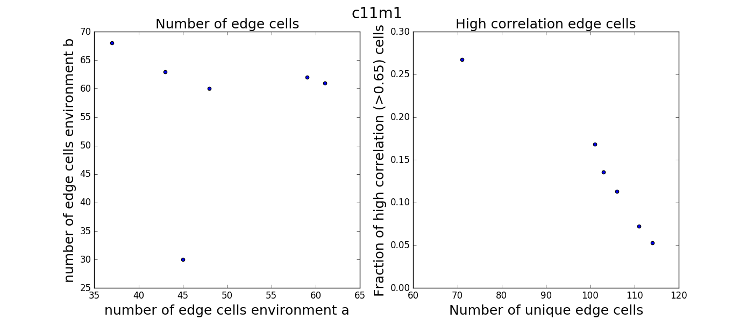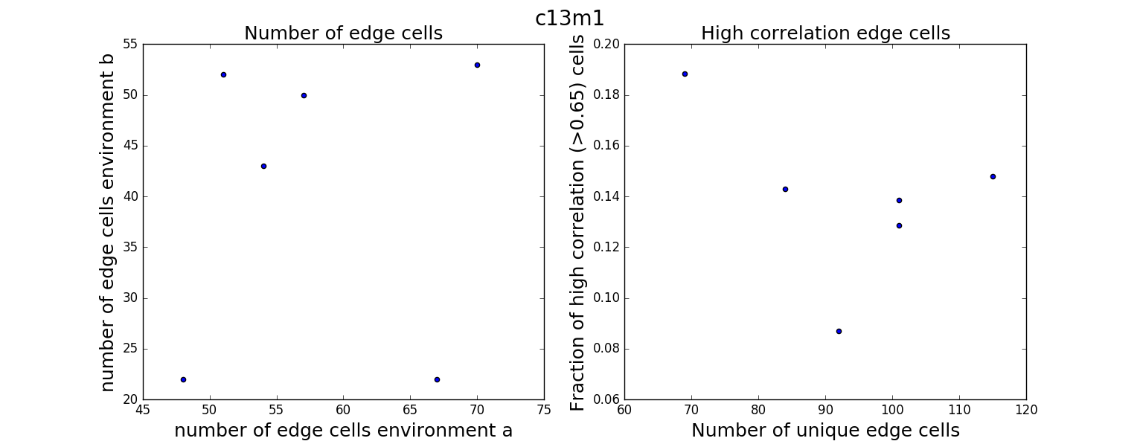

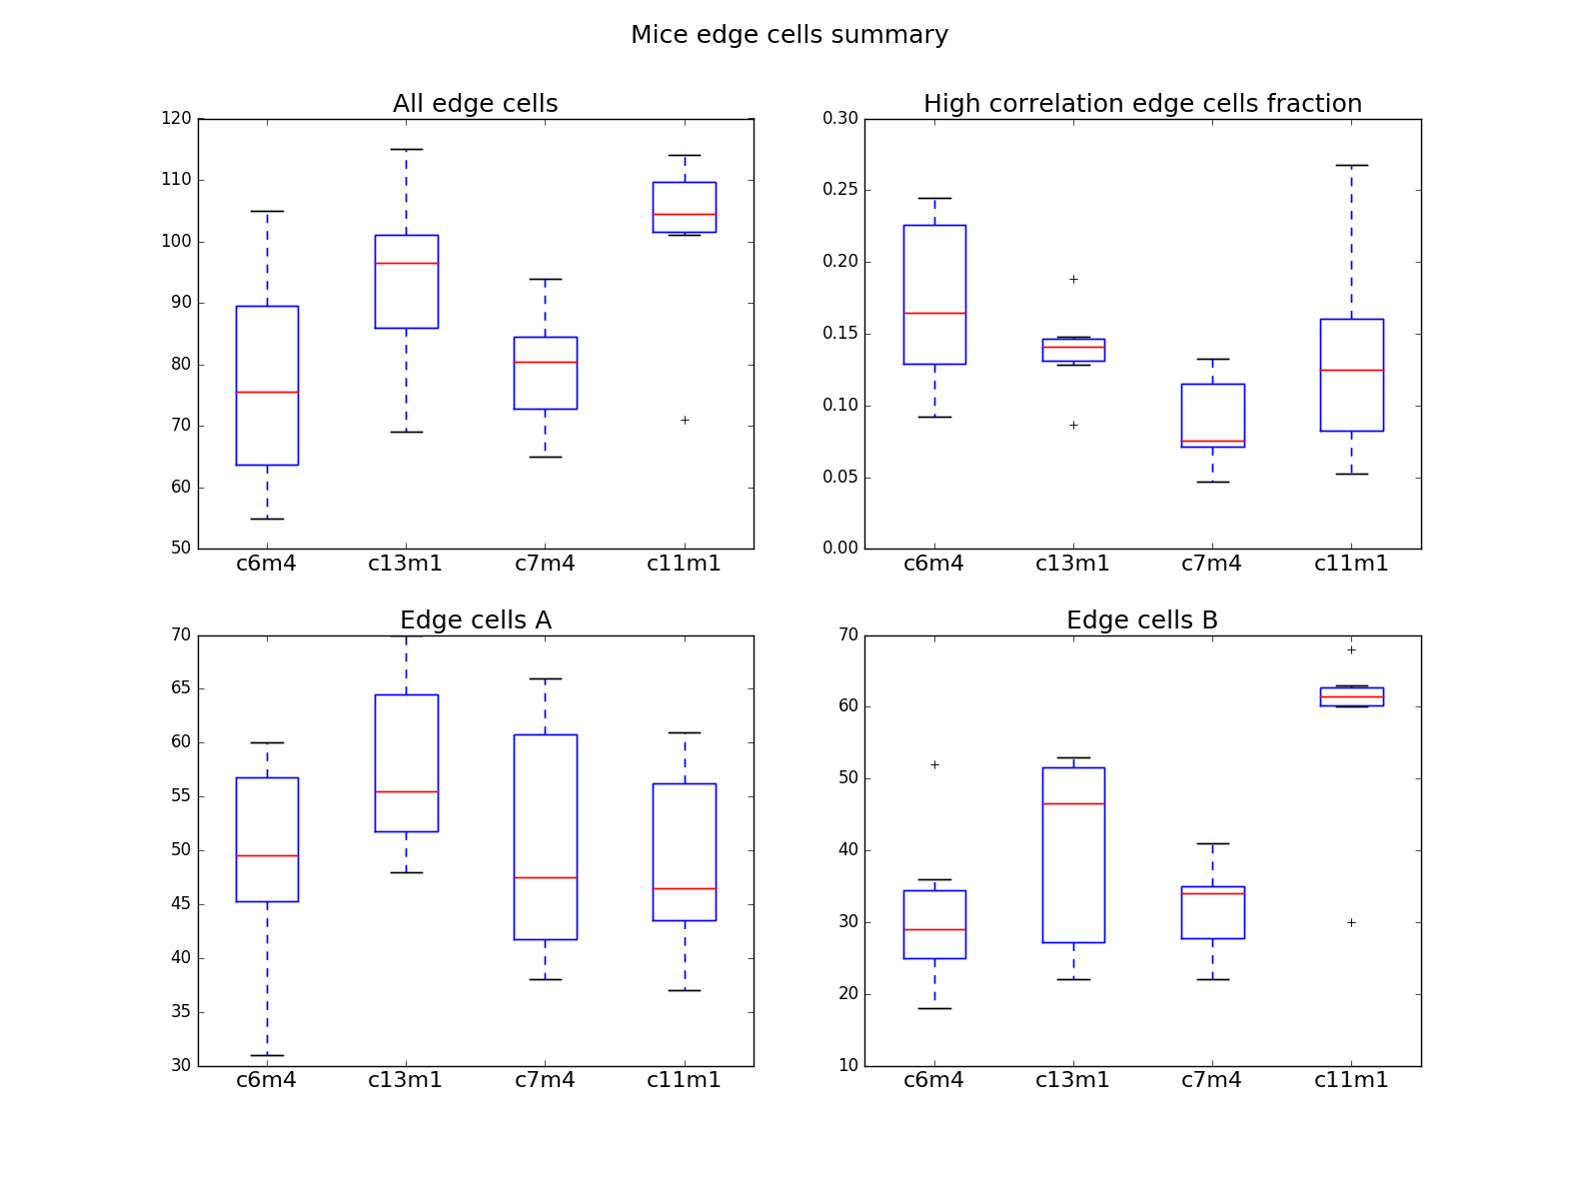

The fraction of the high correlation edge cells do remind the numbers at (Gauthier and Tank, 2018), yet it is variable through parameter choosing.